Predictive Master Notes

# Data Science Glossary

[Data Science Glossary](https://avalara1-my.sharepoint.com/personal/alex_carter_avalara_com/Documents/Documents/My%20Docs/Alteryx/Predictive%20Master%20Exam%20RECERTIFICATION/Data%20Science%20Glossary.pdf)

# Data Investigation Concepts

*Feature Engineering* is using the data you have to generate the data you don’t.

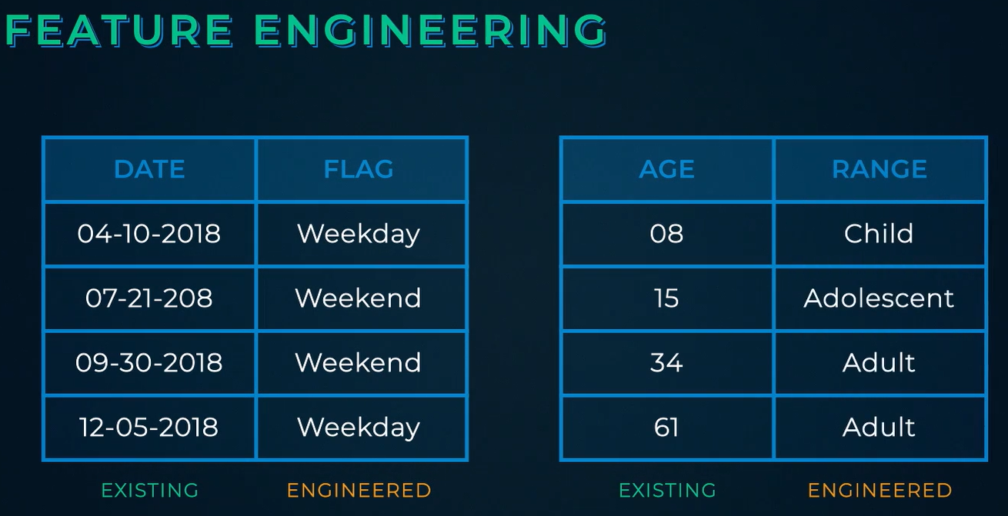

*Collinearity* is when two variables provide similar information to the model.

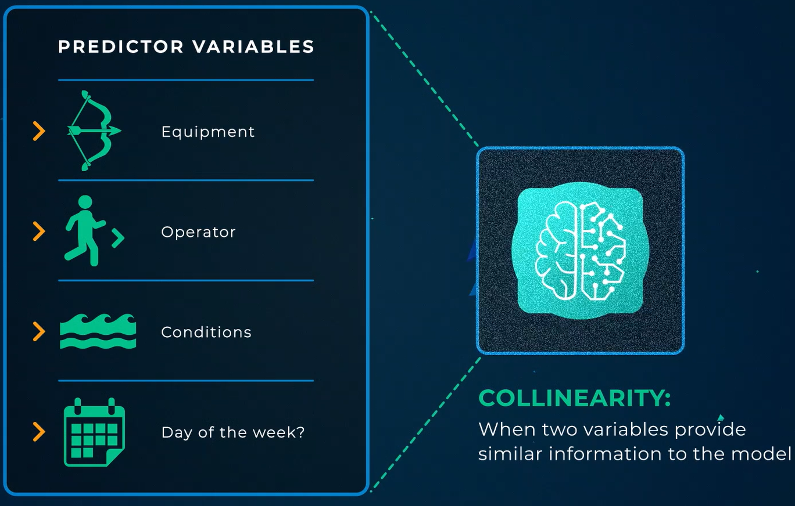

The simplest model is preferred when performance between models is similar (i.e., parsimony). If your historical data has a field that won’t be captured going forward, then you don’t want to include that field in the model (this is a means of “future proofing”).

The *Field Summary* tool is a great tool for investigating a dataset.

The *Frequency Table* tool is used to get counts of values within a field. However, this tool does not accept the following data types:

1. Fixed Decimal
2. Float
3. Double
4. Date/Time
5. Blob
6. Spatial Object

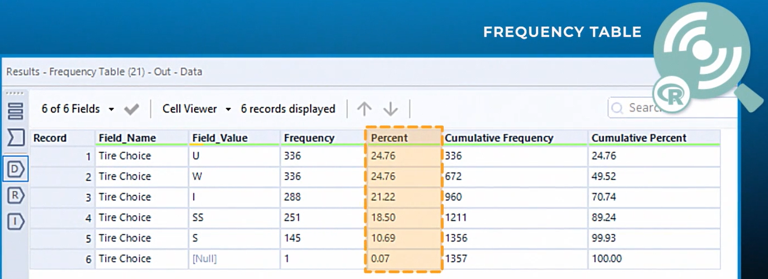

The *Scatterplot* tool is useful for visualizing the relationship between two continuous or binary categorical variables. Scatterplots do not necessarily prove a relationship.

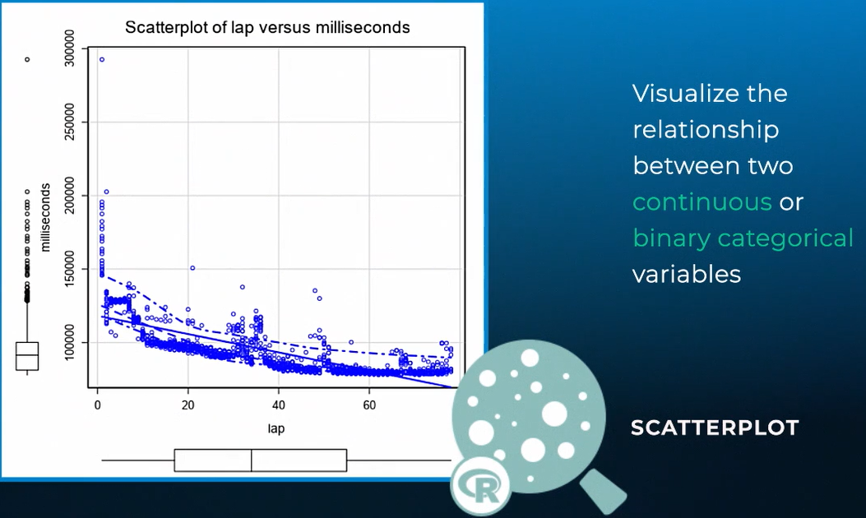

The *Pearson Correlation* and *Spearman Correlation* tools provide a way to see relationships between two continuous variables.

The *Pearson Correlation* tool measures the strength of a linear association between two variables.

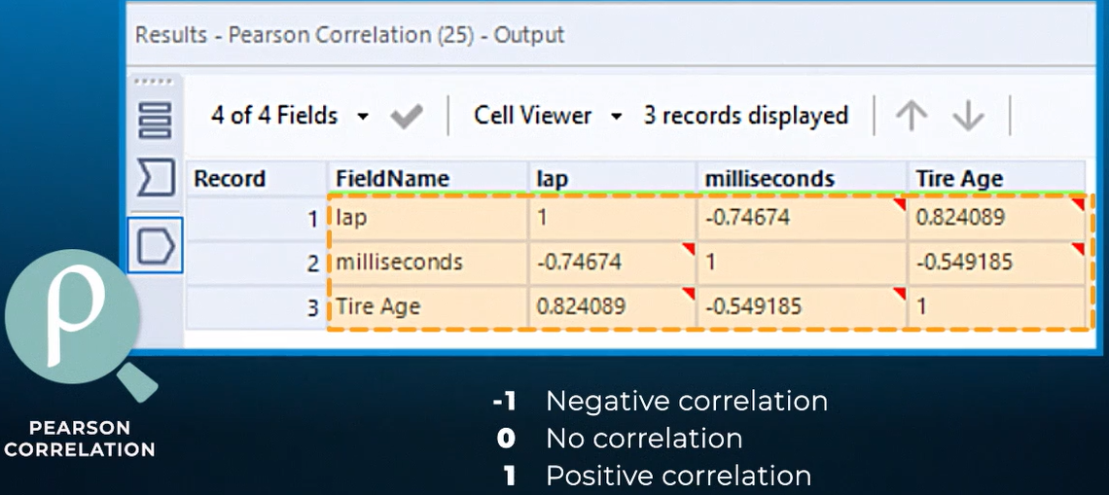

The *Spearman Correlation* tool evaluates the [monotonic](https://en.wikipedia.org/wiki/Monotonic_function) relationship between two variables. The variables must be continuous (i.e., any value within a range, including fractions and decimals) or ordinal (e.g., first, second, third, etc.). If ordinal, the values must be ranked so the order of the relationship can be determined. For example, we can’t say that *green* is a step up from *red*. However, *large* is greater than *small*.

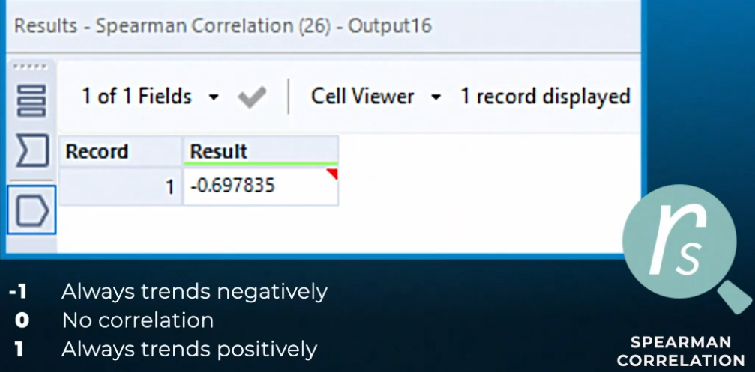

The *Association Analysis* tool creates a full correlation matrix of numeric variables.

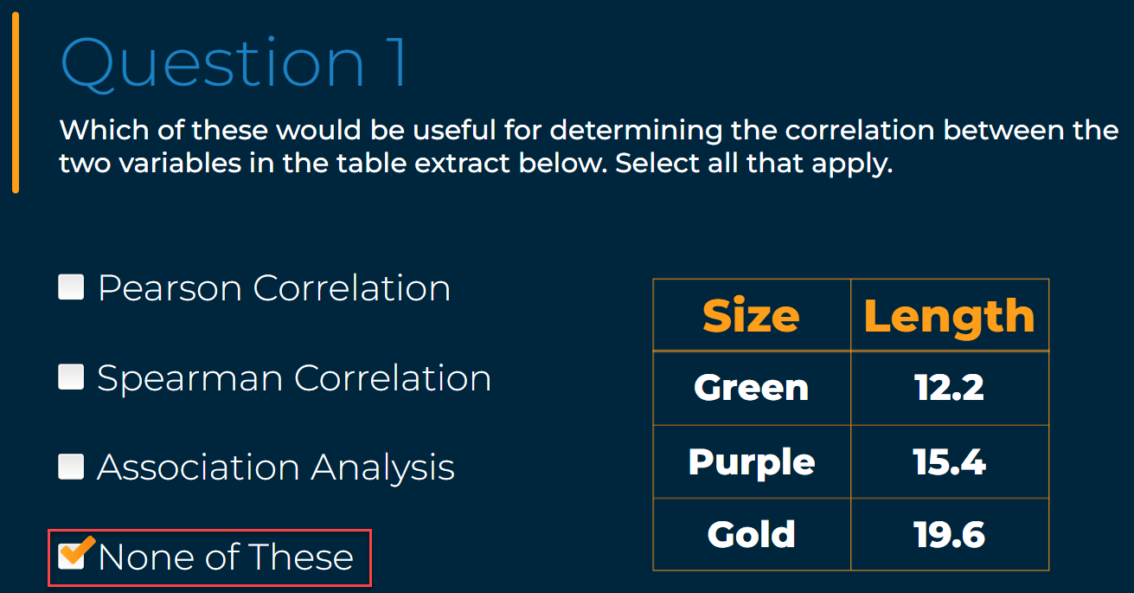

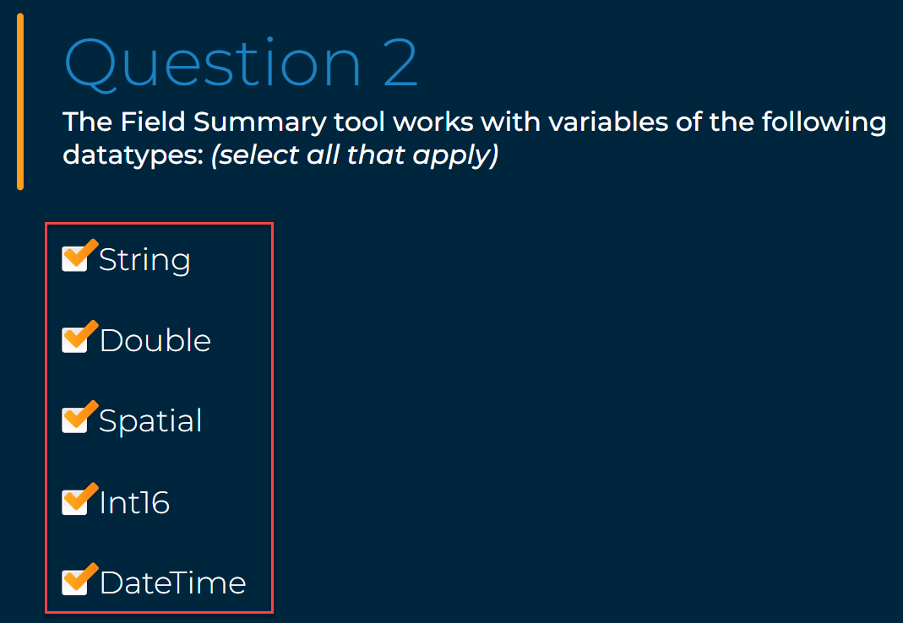

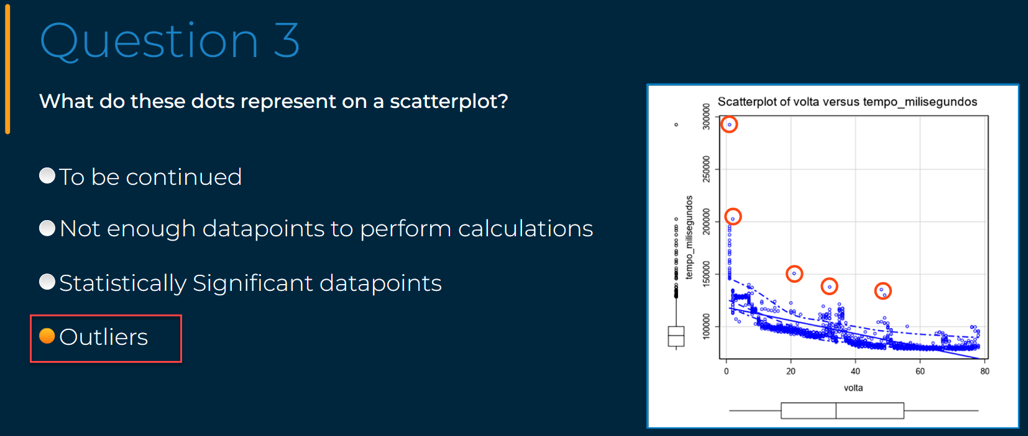

# Data Investigation Techniques

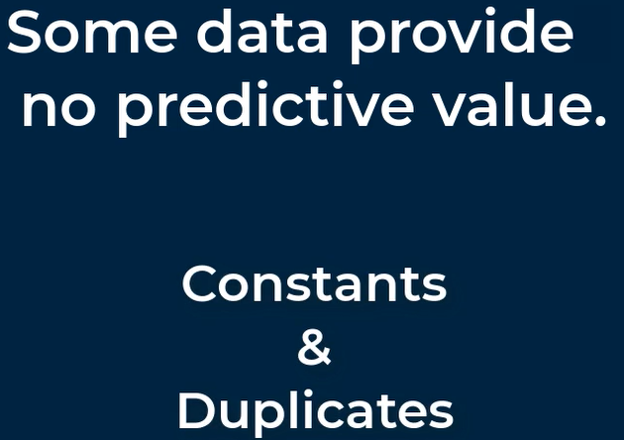

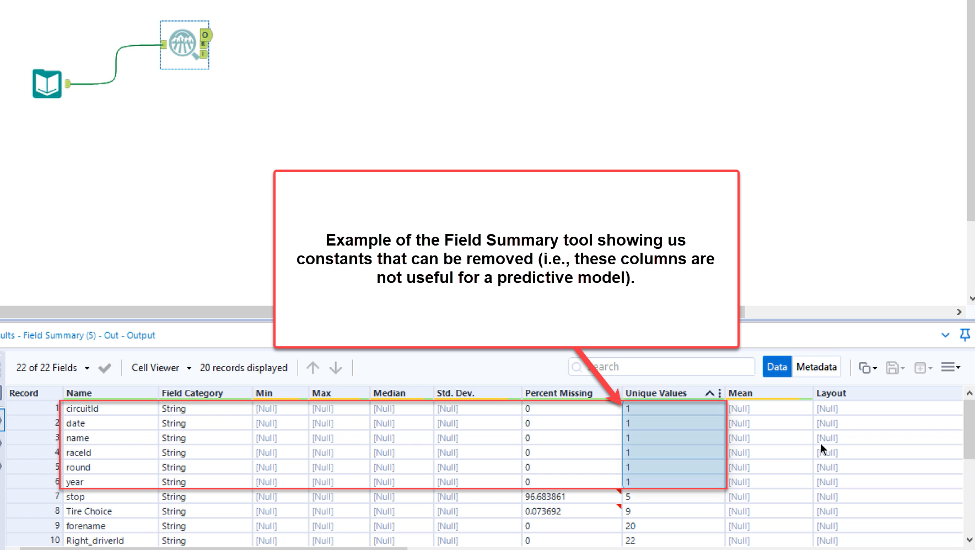

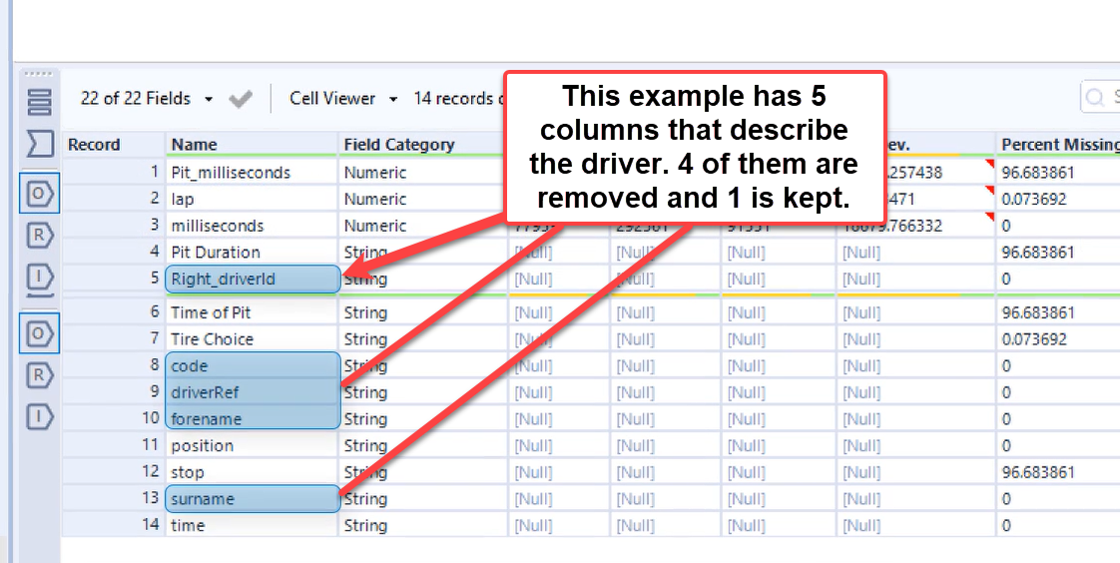

Generally speaking, an *outlier* is a value that is more than 2 standard deviations from the mean.

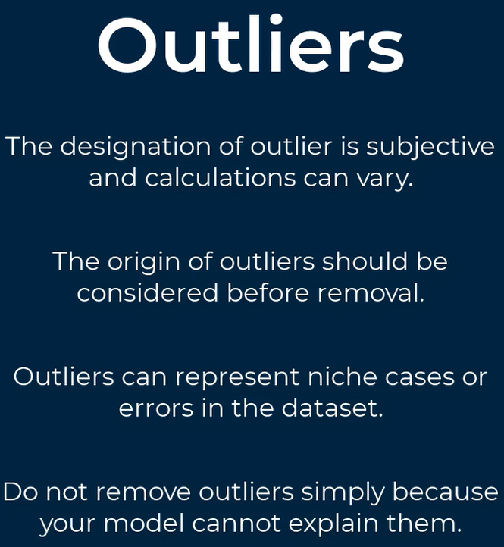

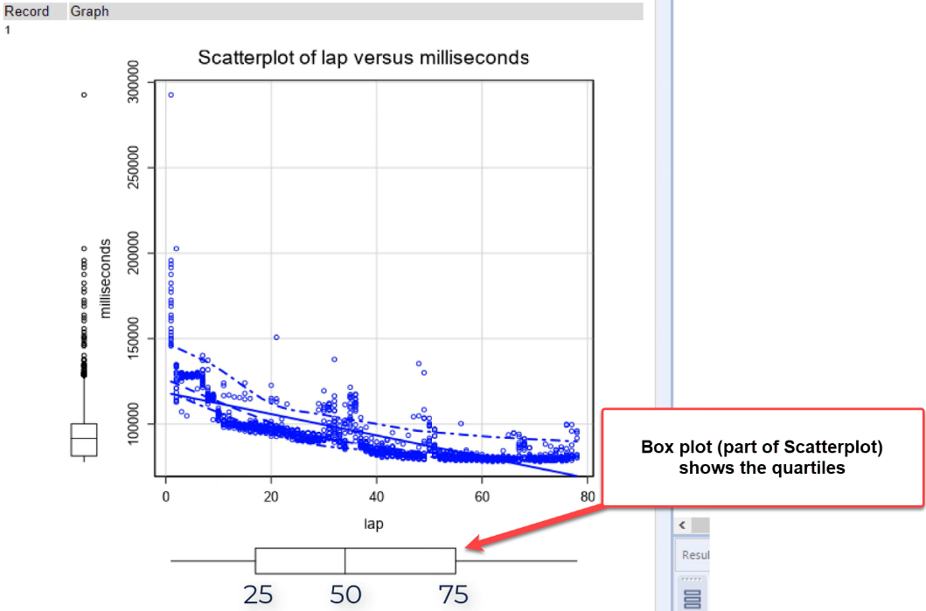

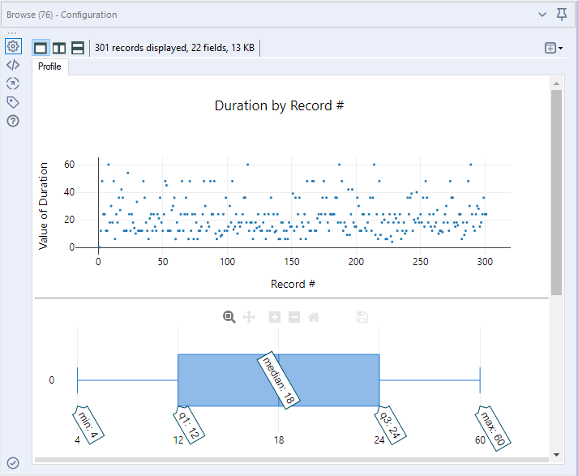

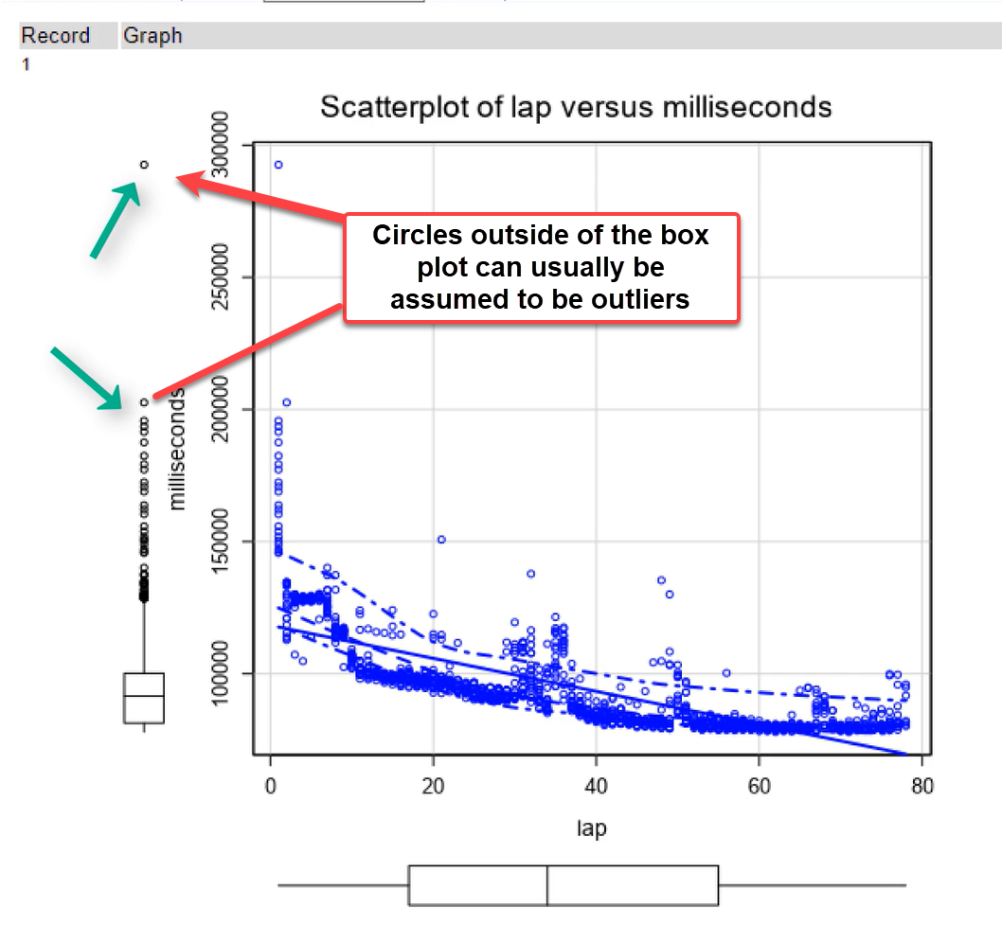

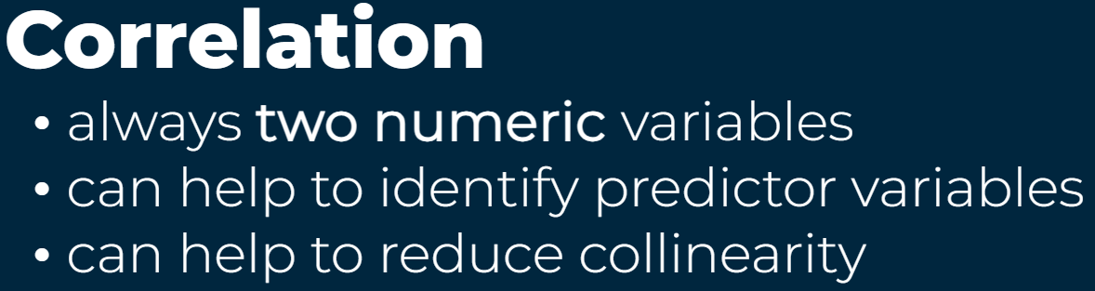





*Plot of Means* (a more visual result) and *Test of Means* (a more concrete result) tools are used to evaluate relationships between continuous and categorical variables. An example from the Plot of Means tool is shown below, where the milliseconds for each tire choice is shown, with *standard deviation* selected for the error bars.

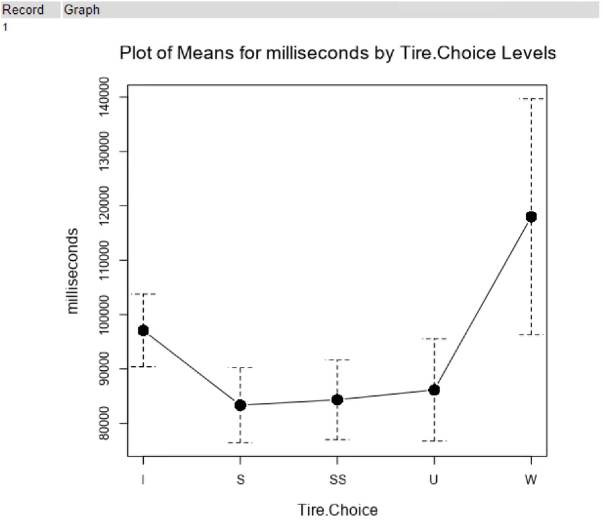

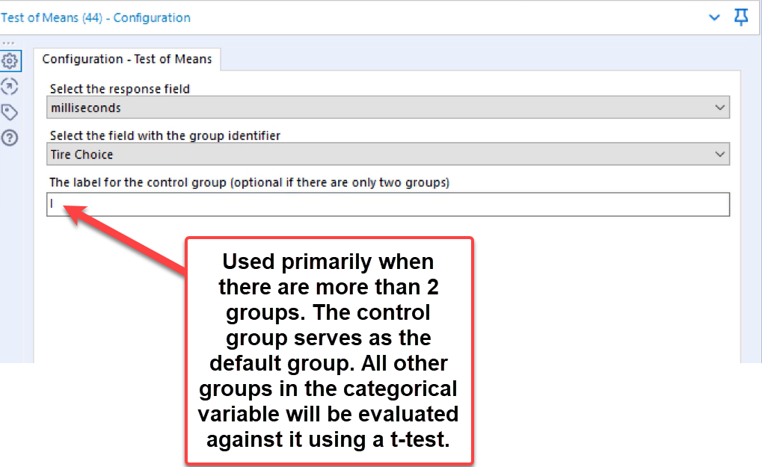

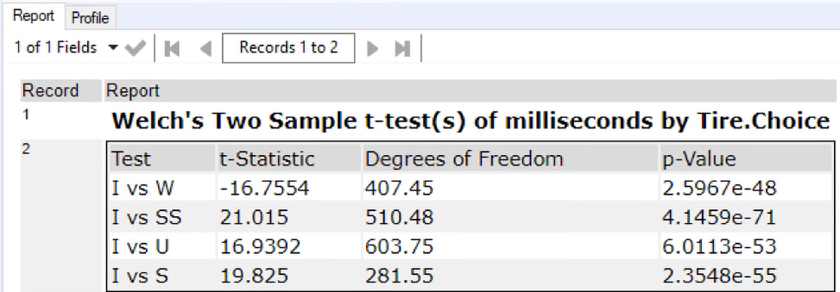



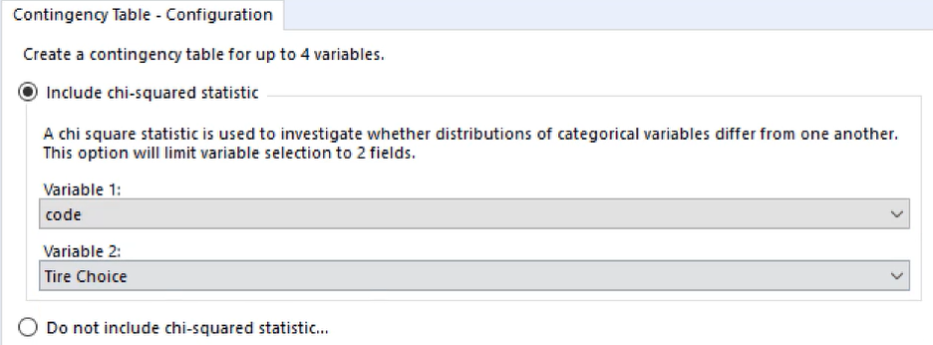

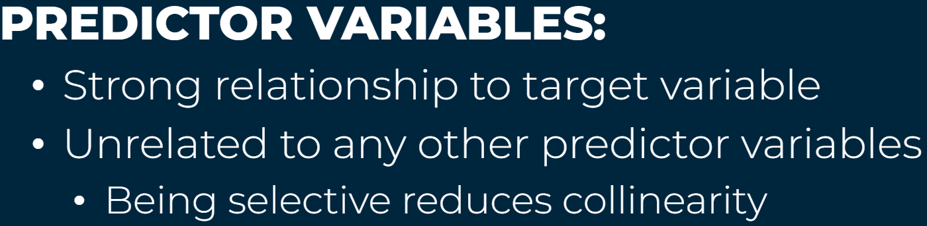

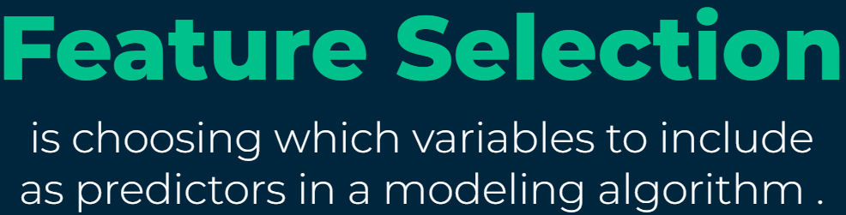

Most data scientists spend the majority of their time in the *Data Investigation* phase of the *Data Science Lifecycle* because there’s no substitute for knowing your data.

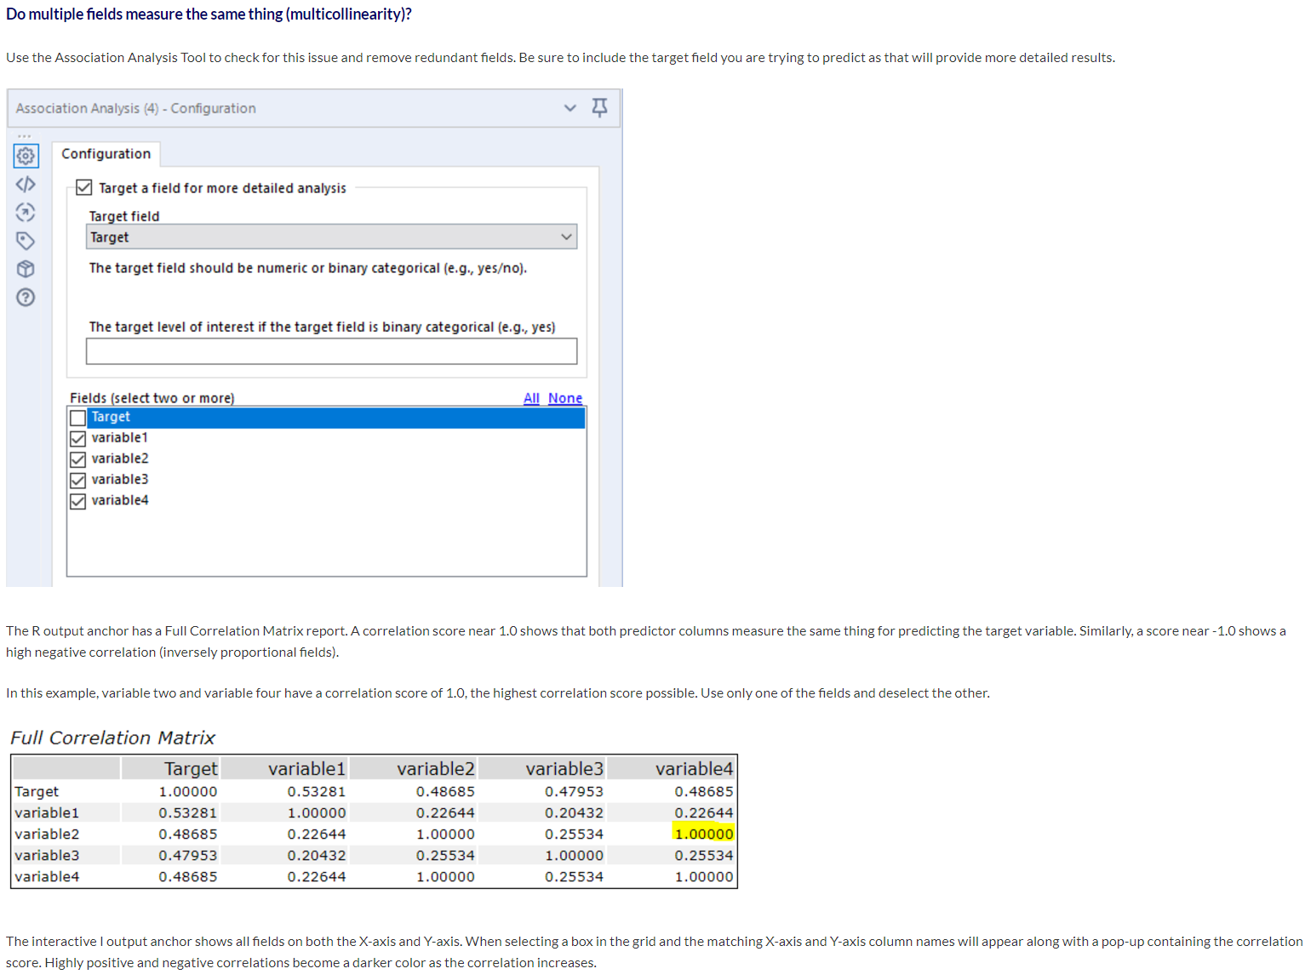

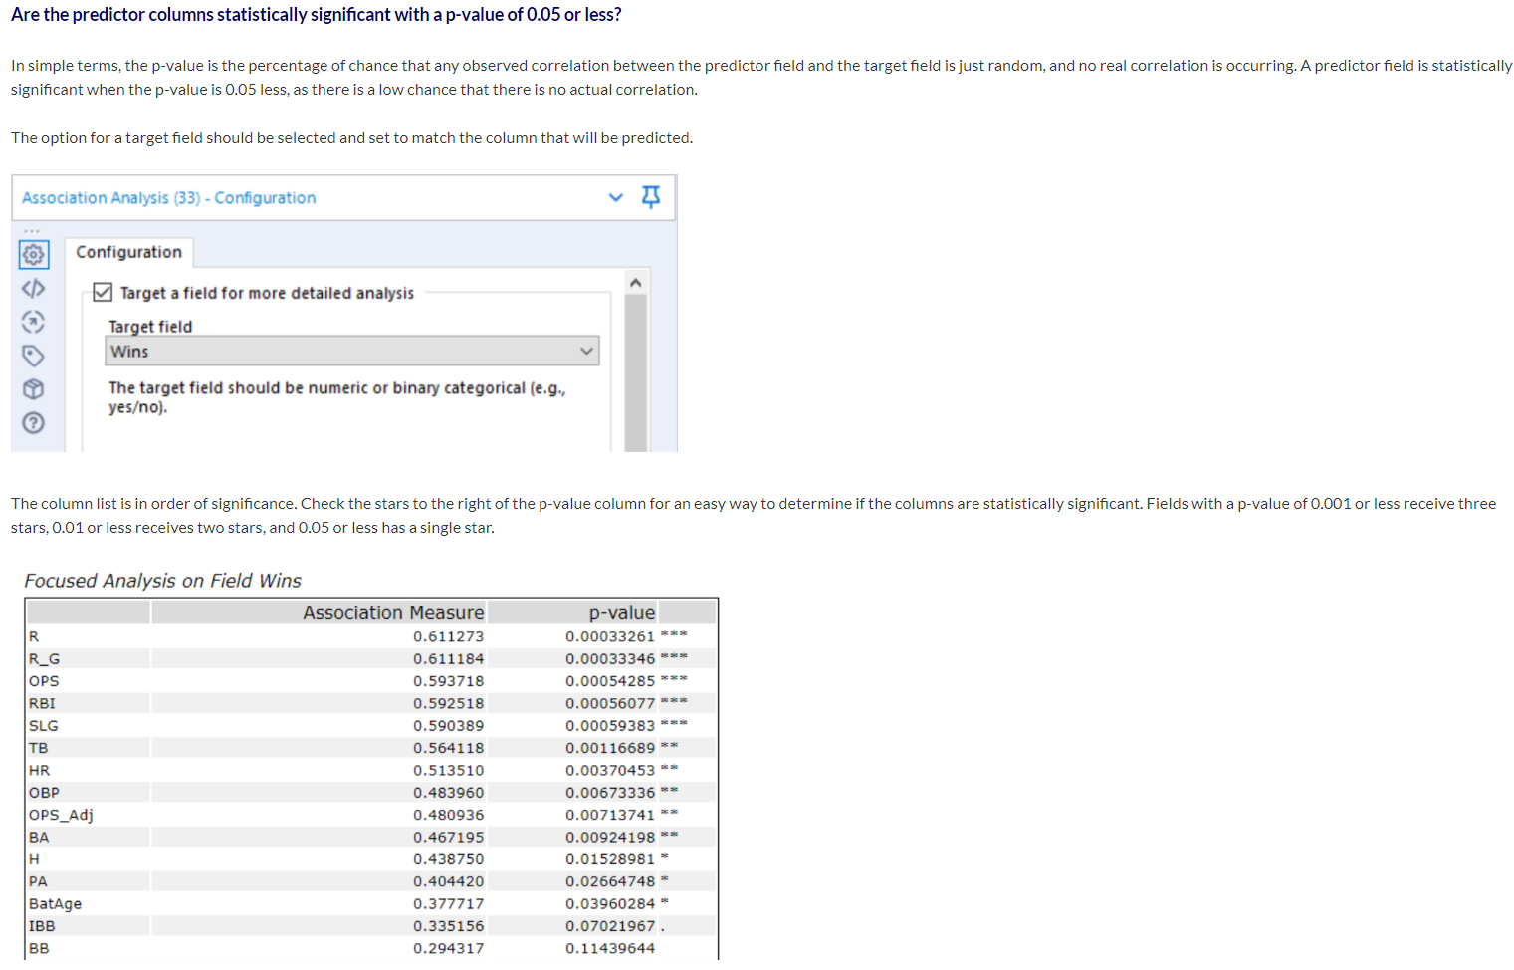

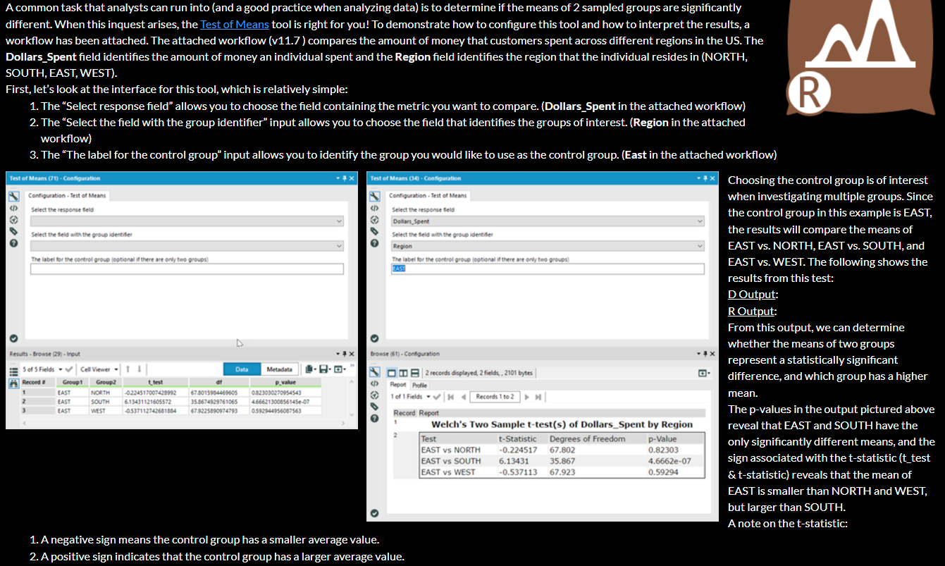

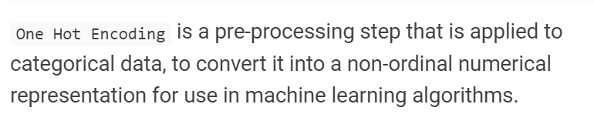

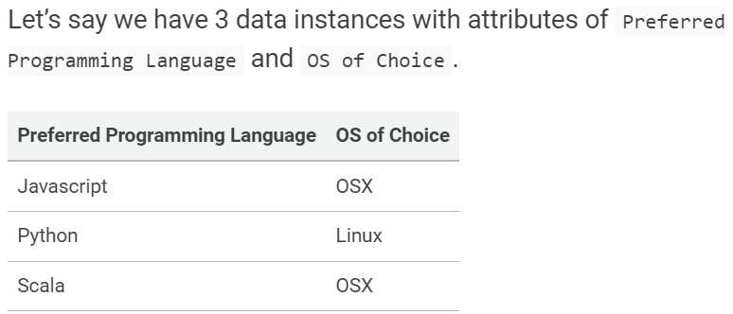

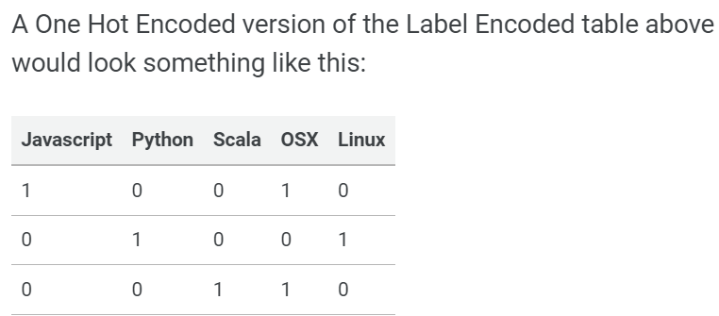

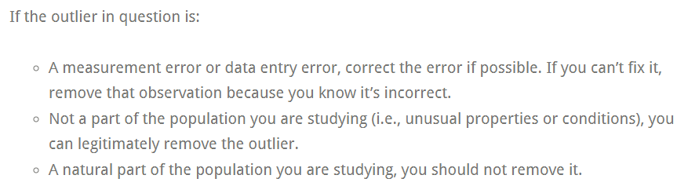

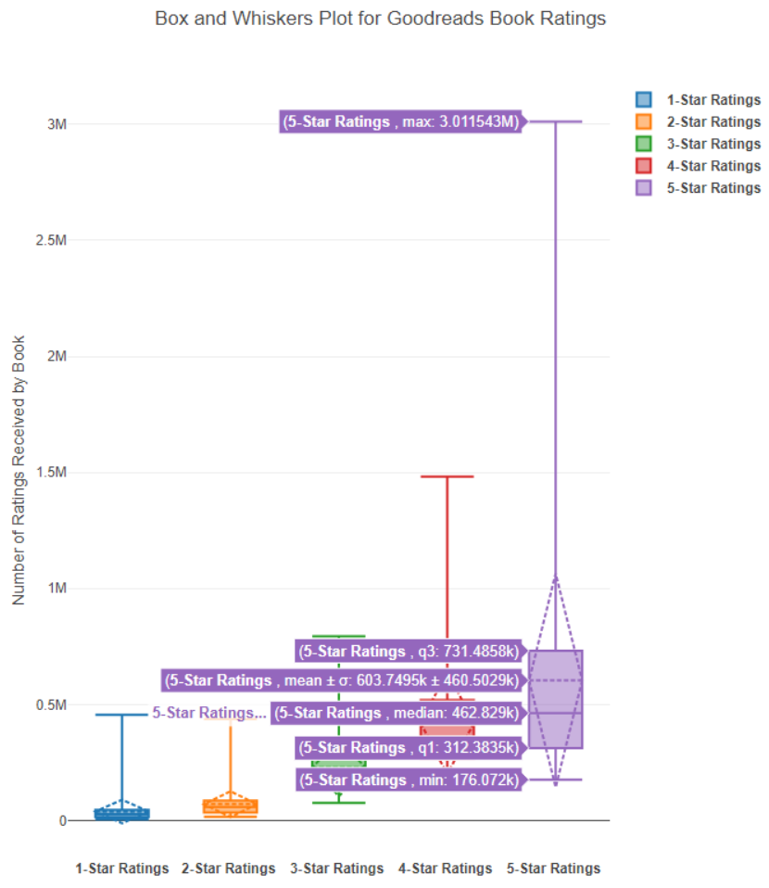

# Predictive Modeling

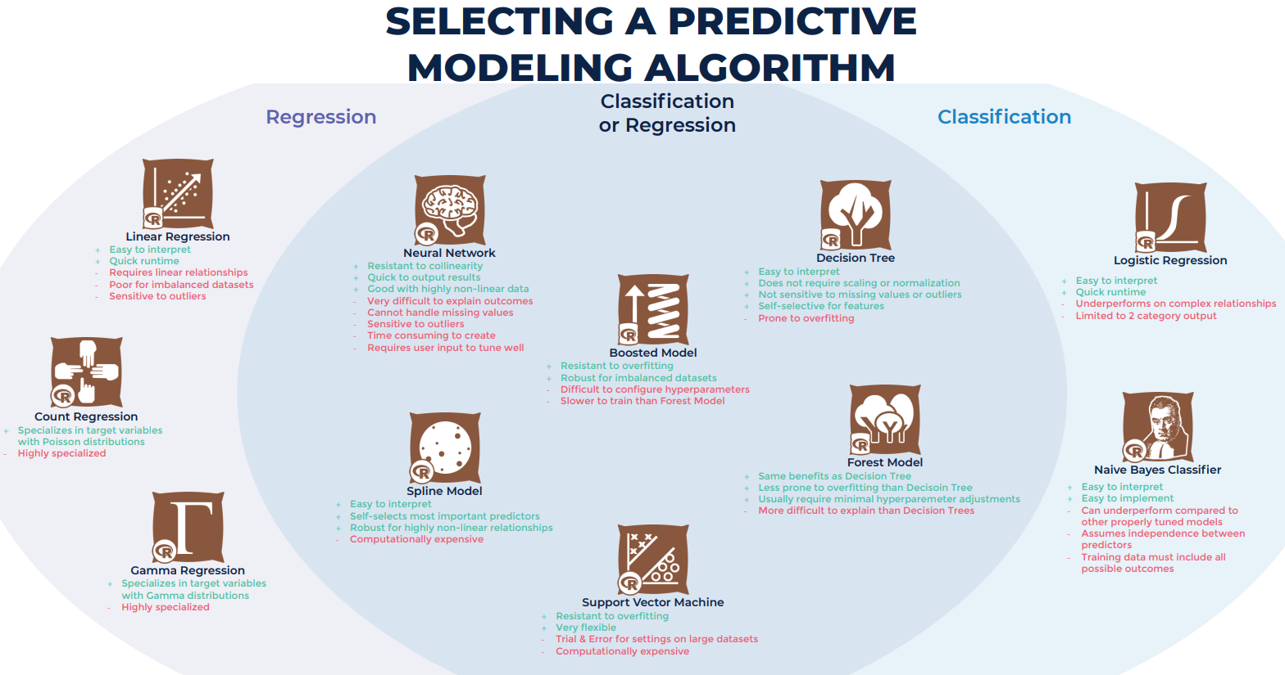

A model is a mapping of the relationships in your data.

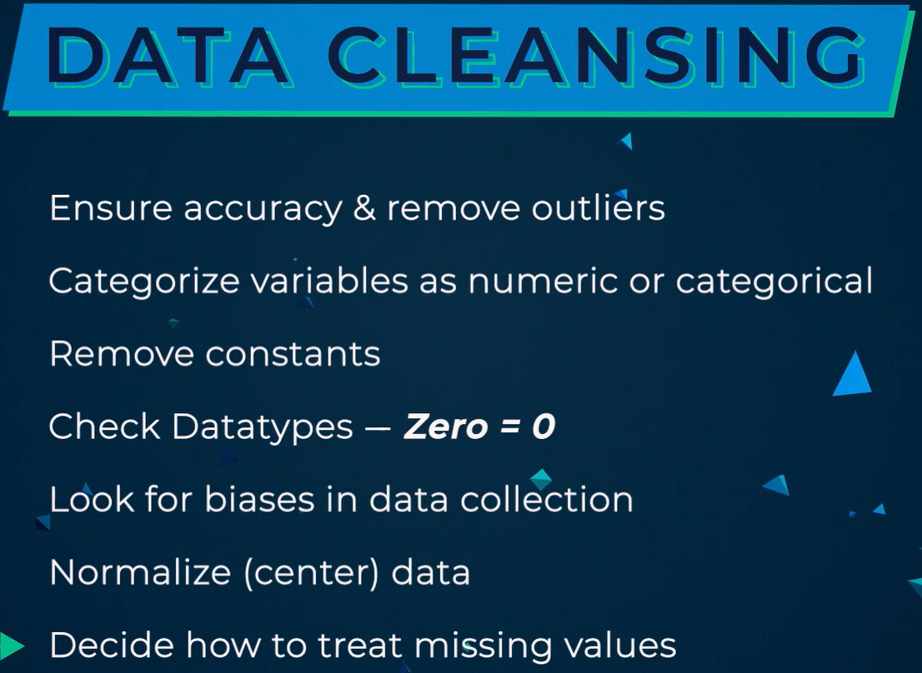

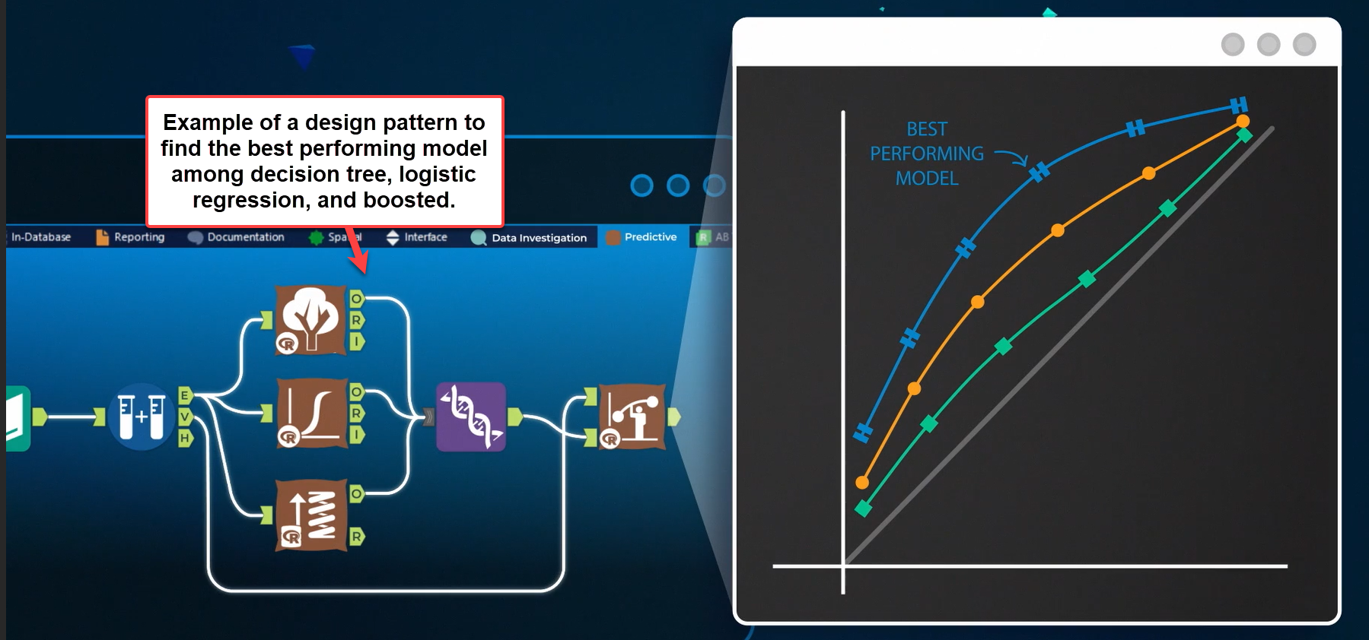

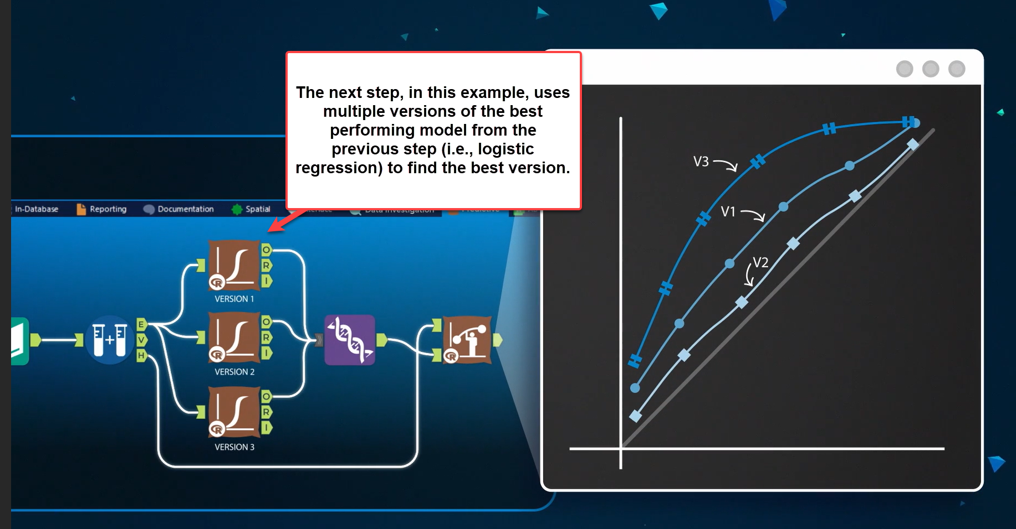

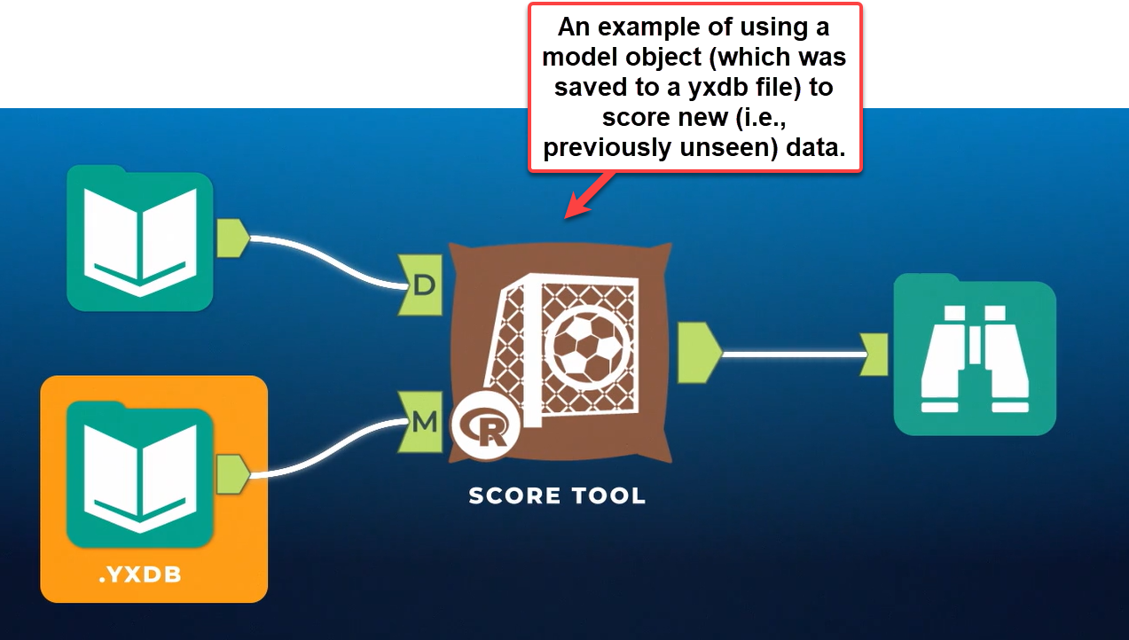

# Predictive Analytics Fundamentals

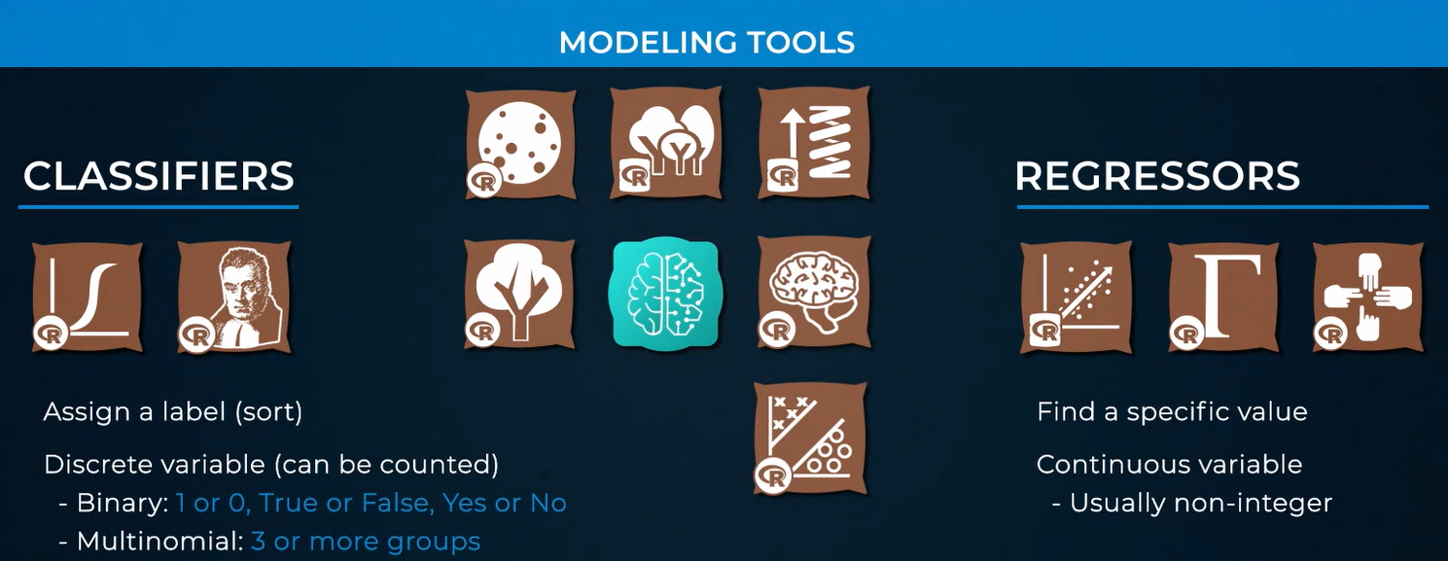

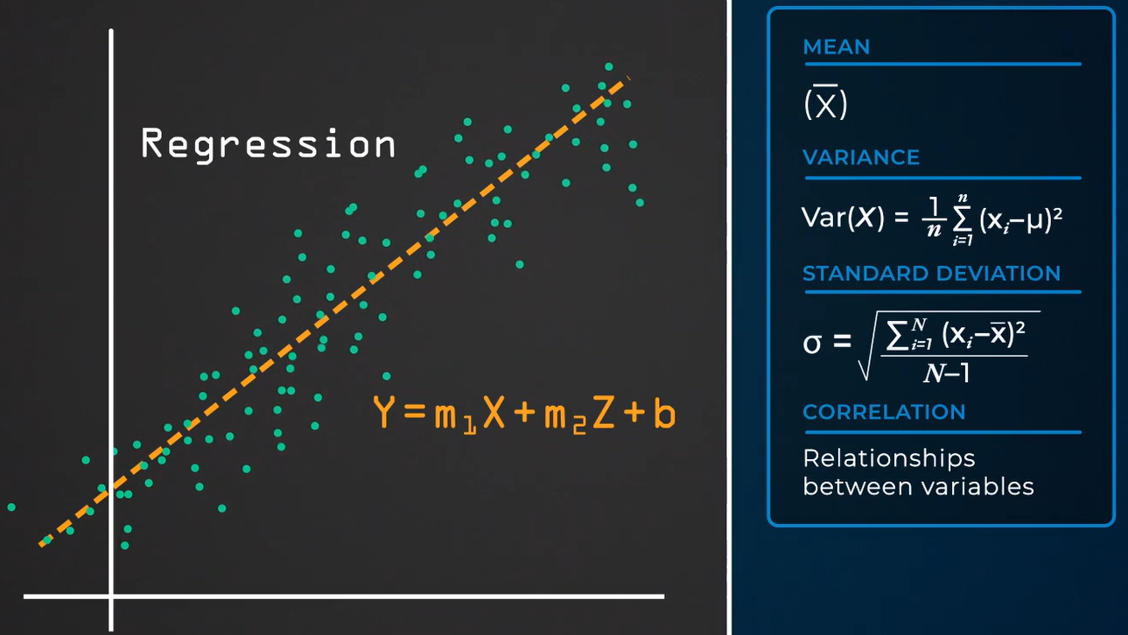

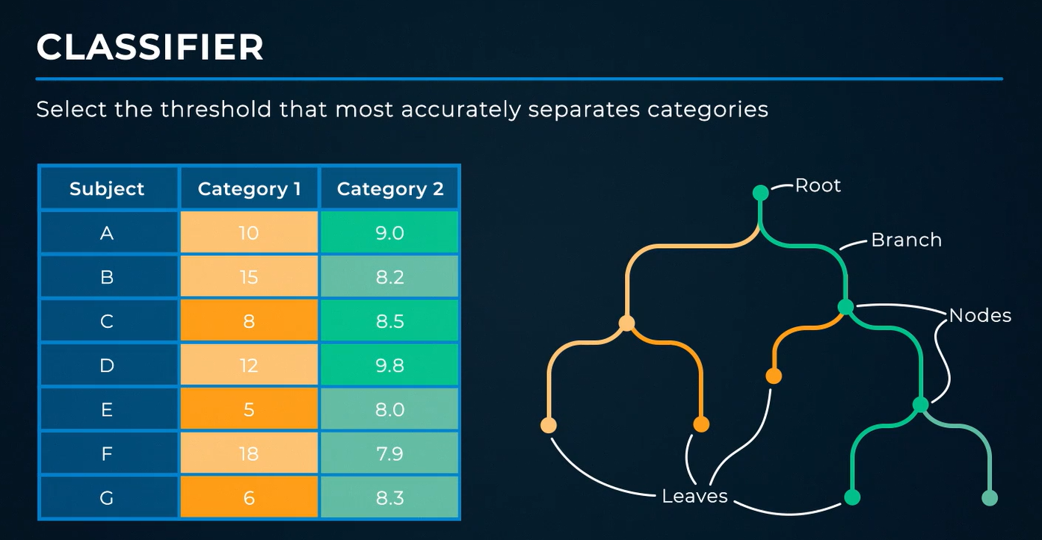

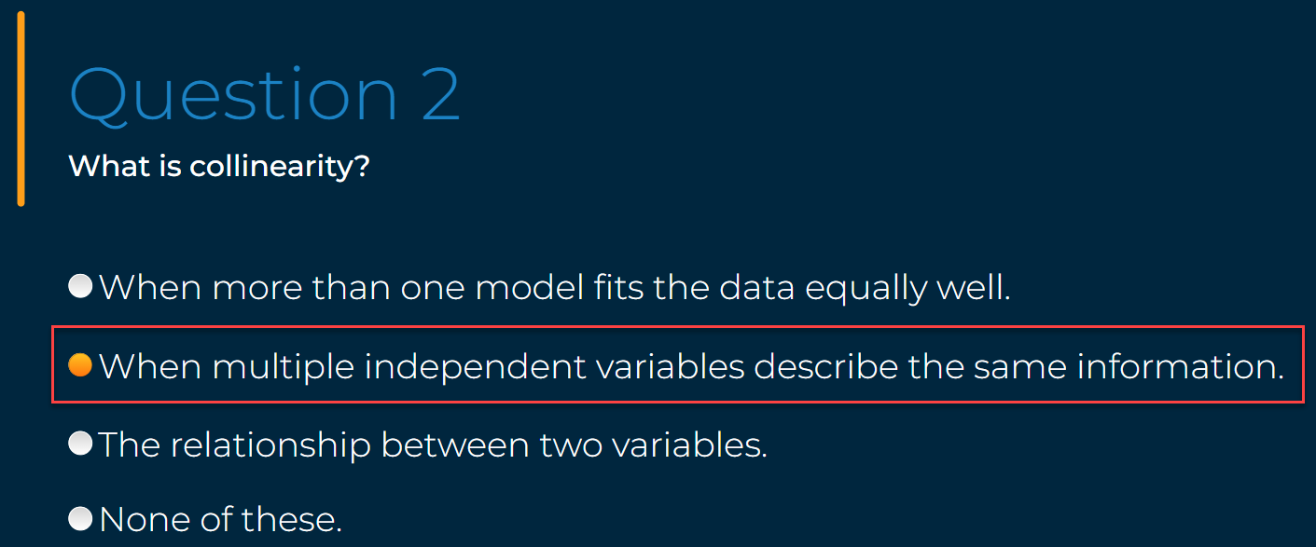

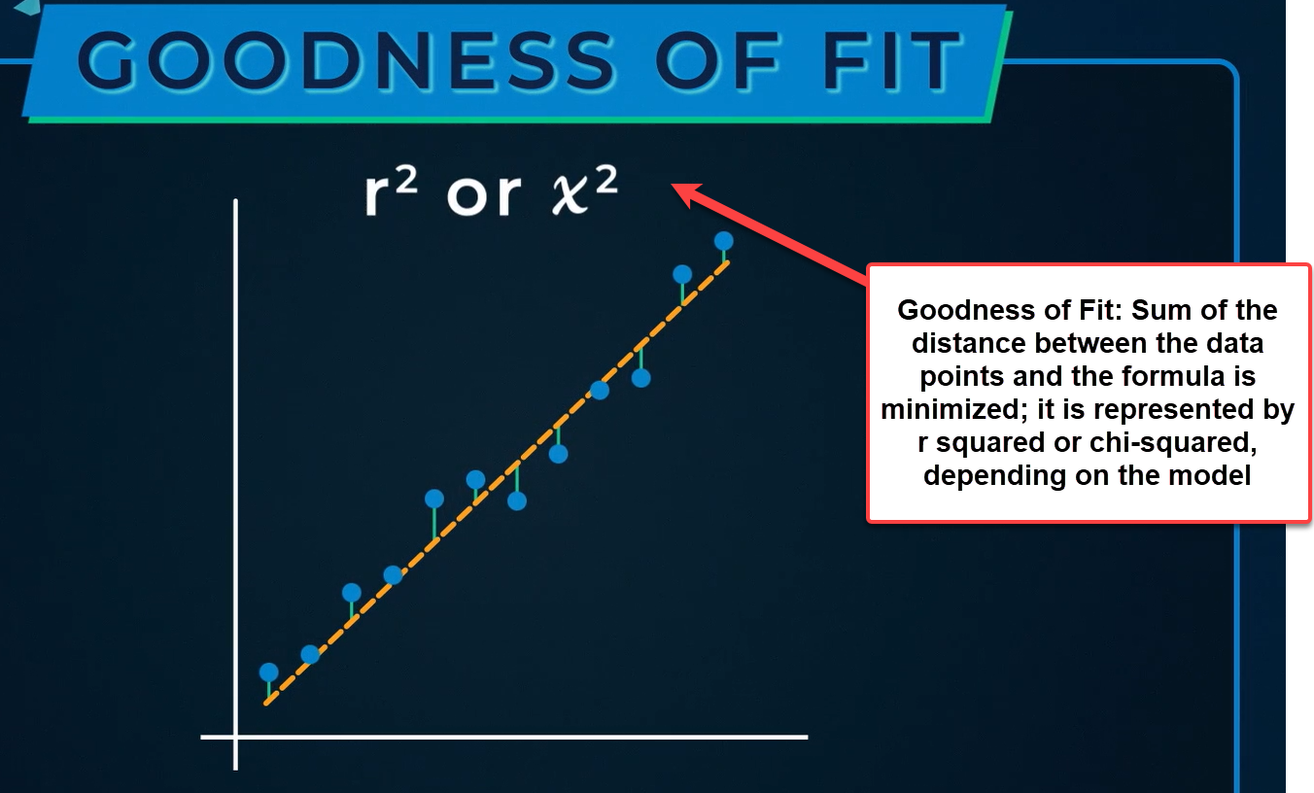

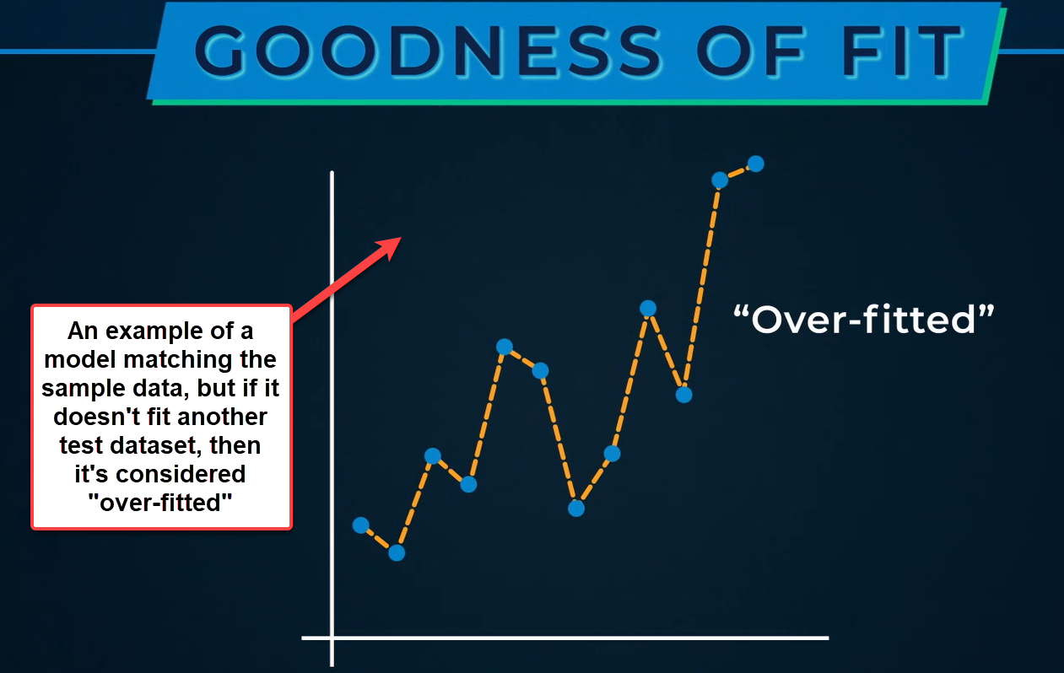

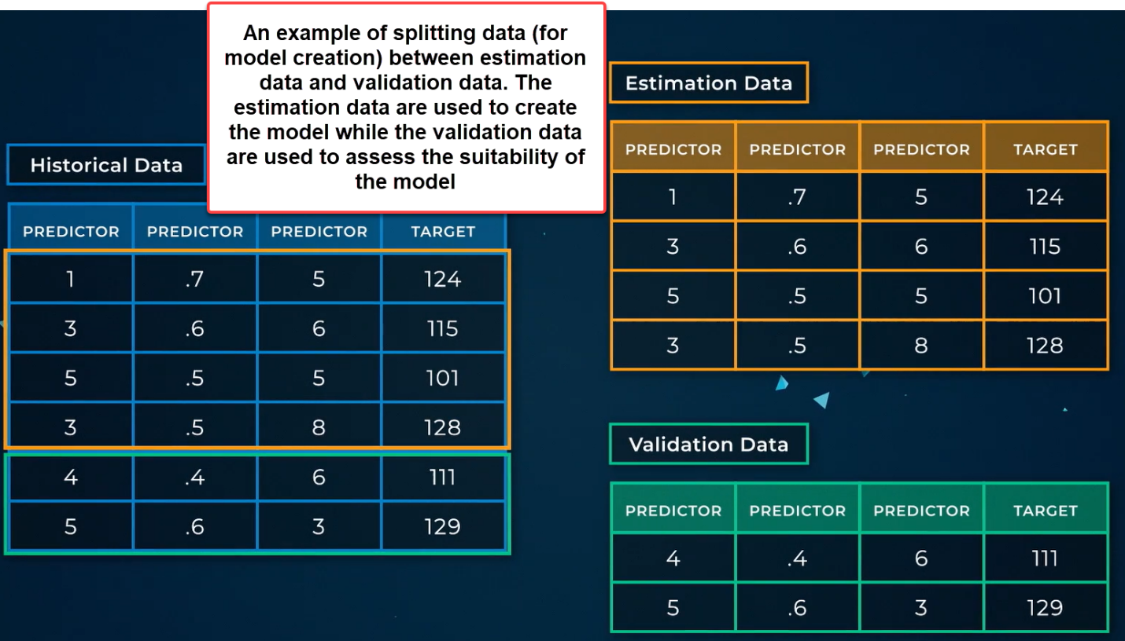

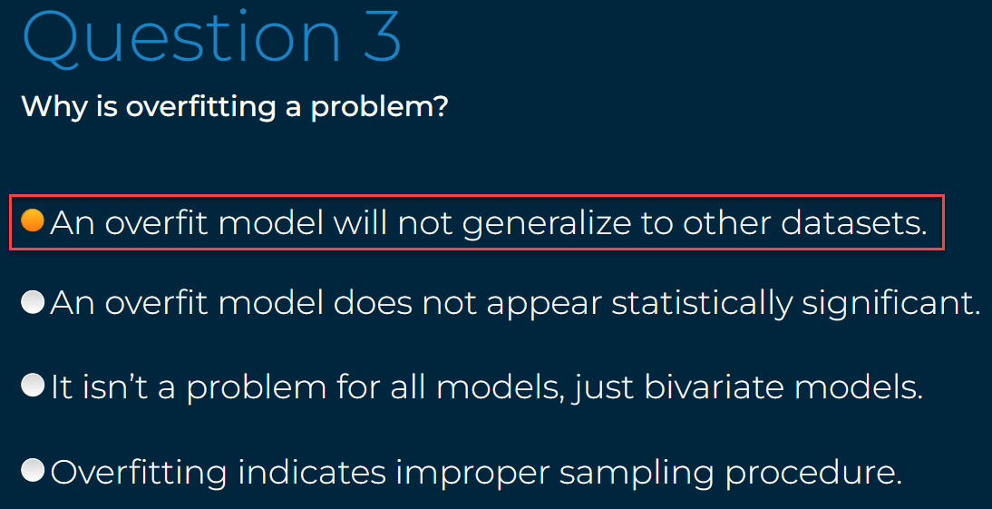

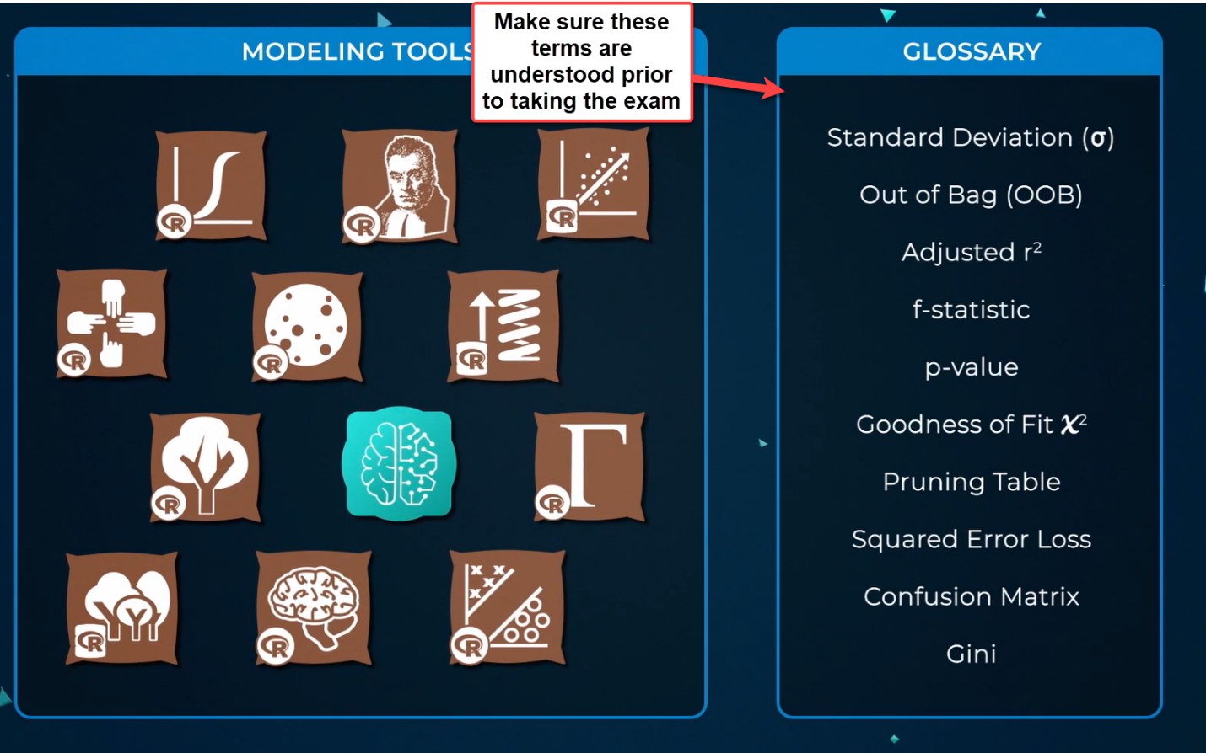

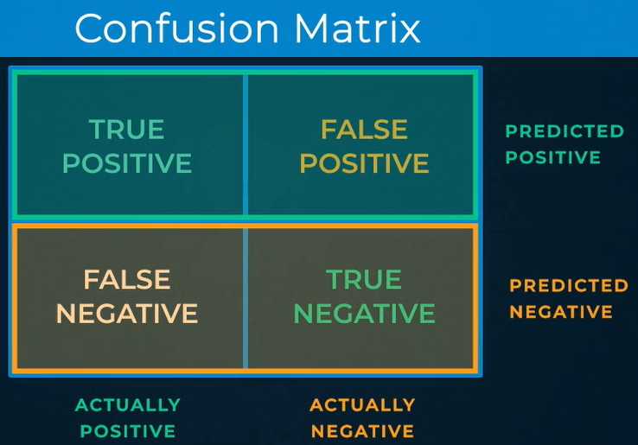

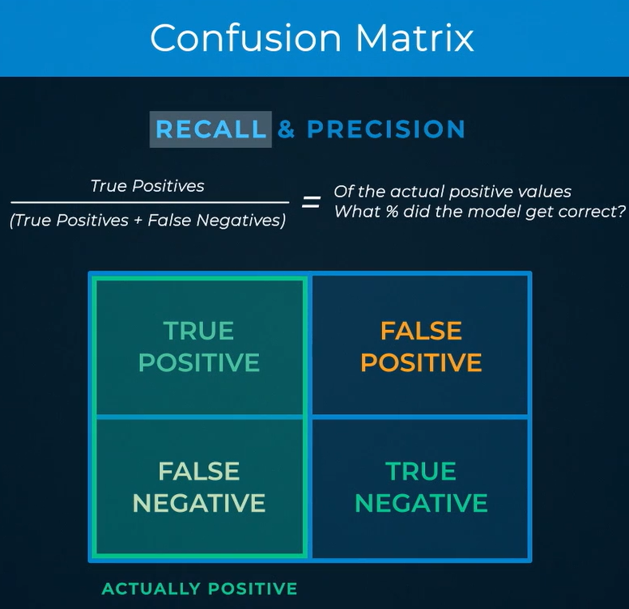

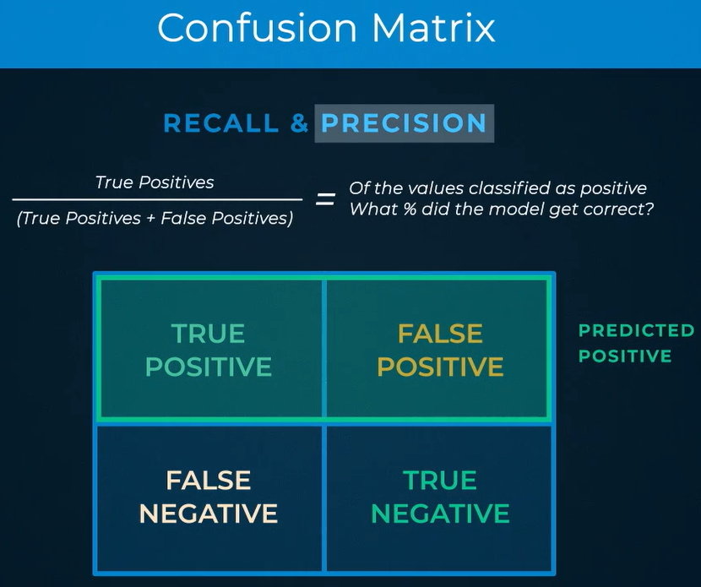

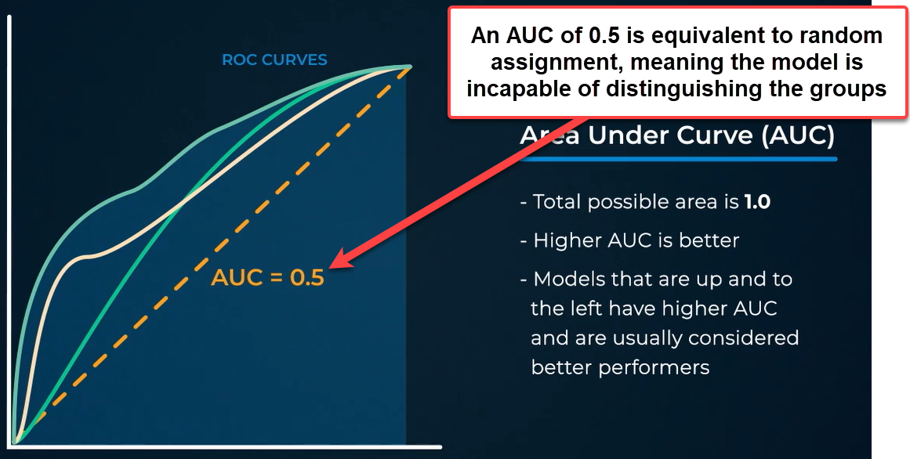

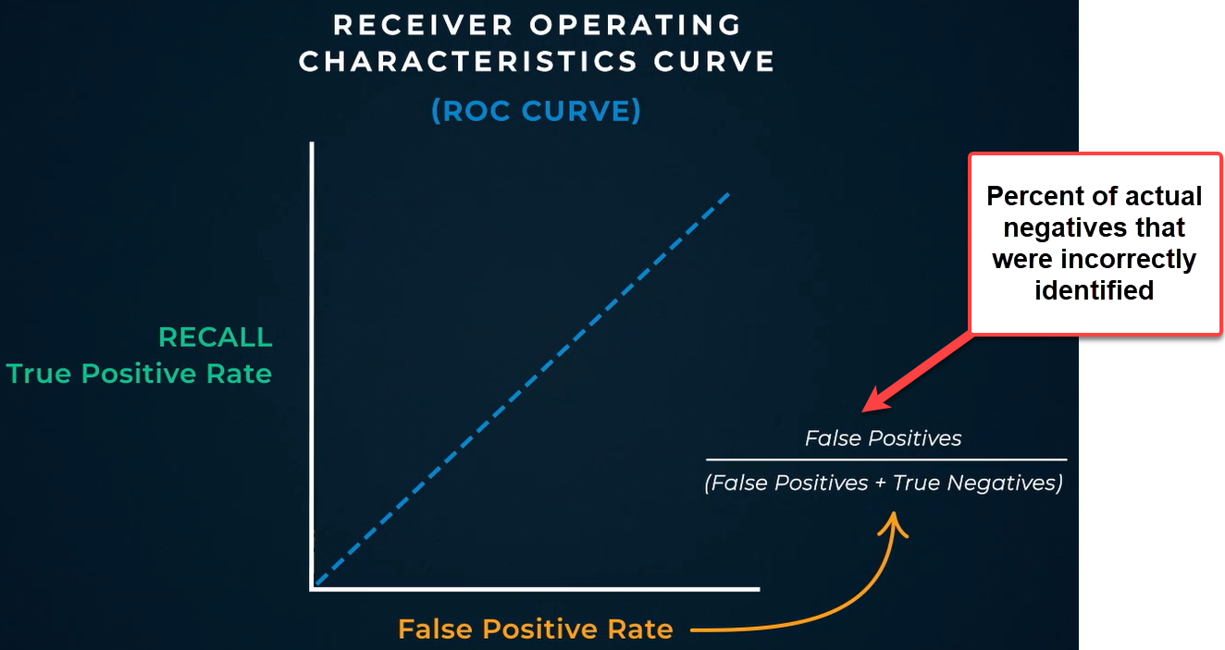

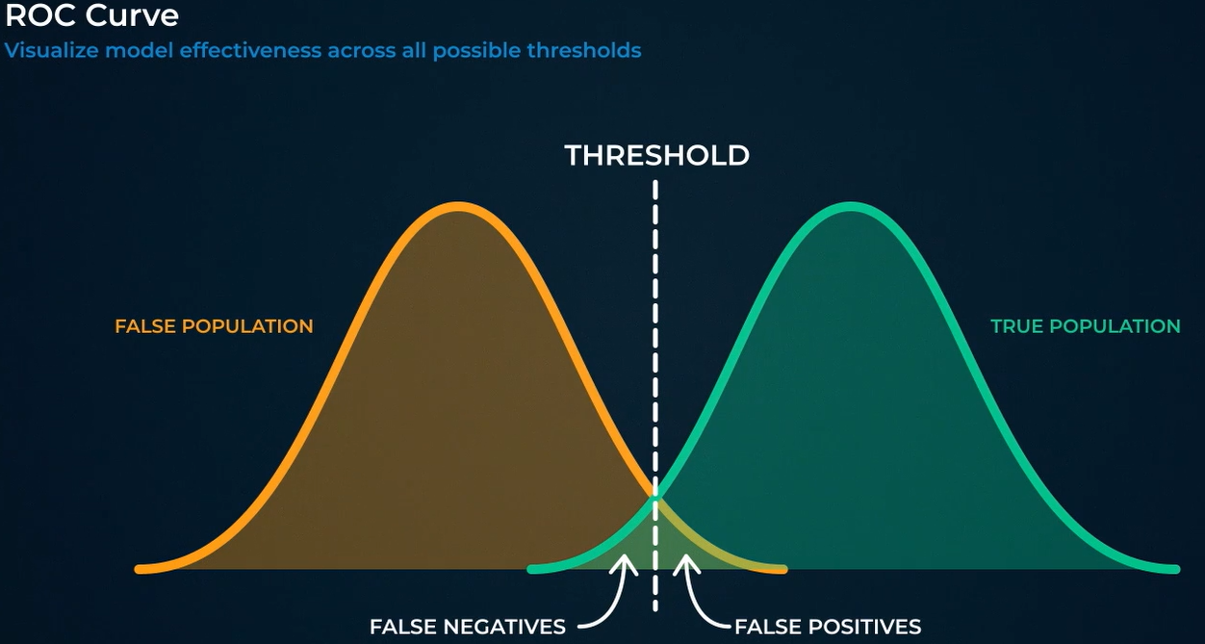

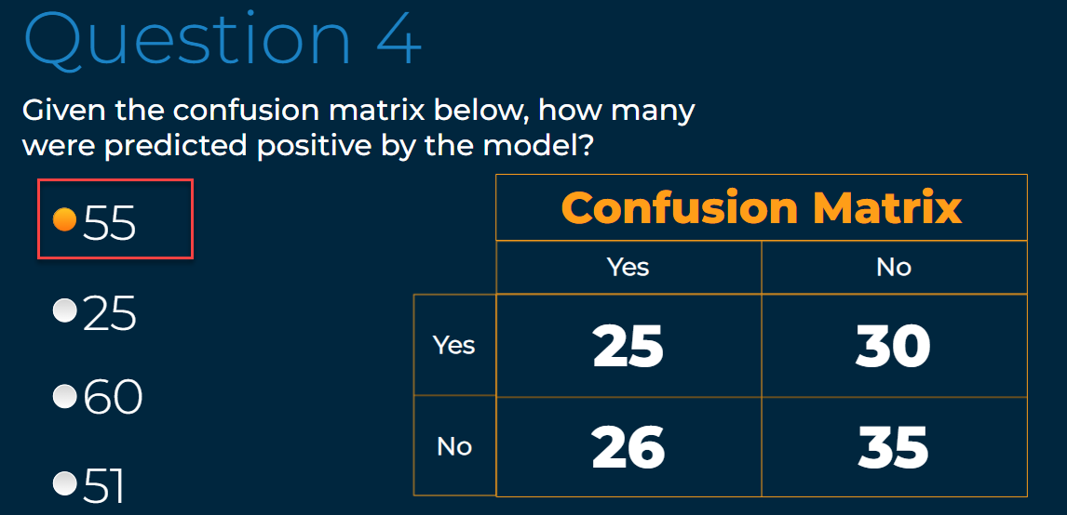

# Creating a Predictive Model

